Supporting Information

A New Method of Synthetic 2,4,6,8-Tetranitro 3,3,7,7-tetrakis(trifluoromethyl)-2,4,6,8-tetraazabicyclo[3.3.0] Alkane
YANG Tong-tong, LIU Yang , HOU Xiao-wen, MENG Zi-hui, XU Zhi-bin

Table of content S1

¹H NMR Spectra S2
¹³C NMR Spectra S3
¹⁵N NMR Spectra S5

¹H NMR Spectra
Figure S1. ¹H NMR spectra of 4
Figure S2. ¹H NMR spectra of 5

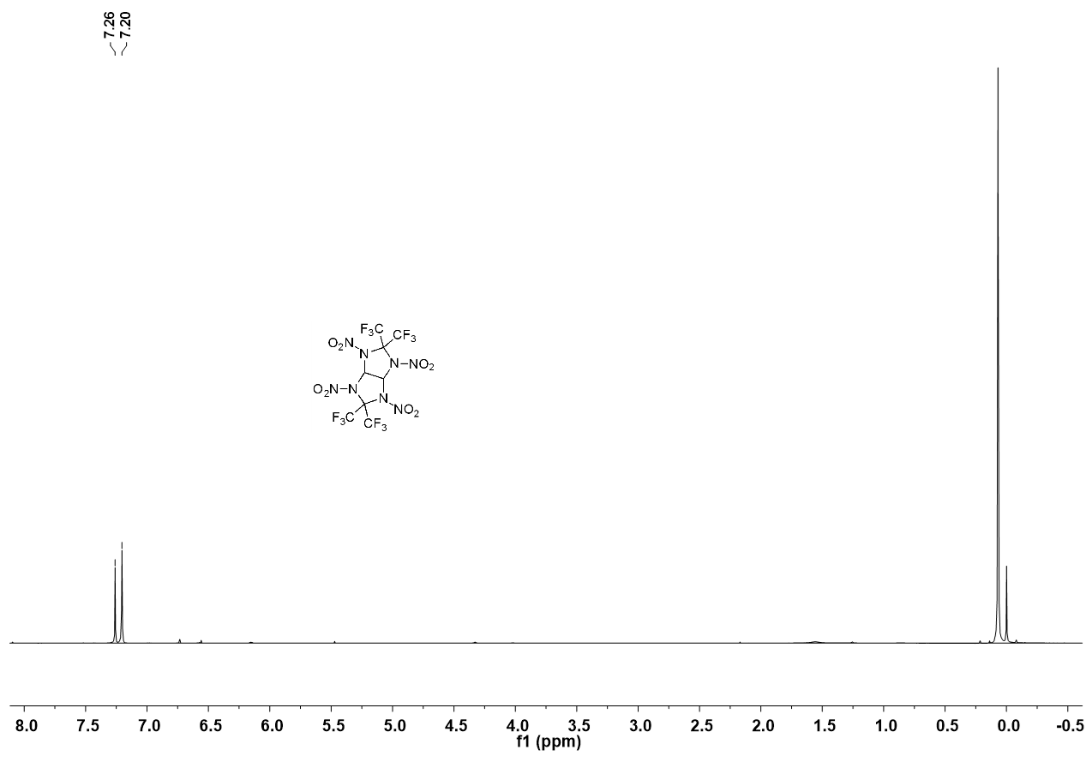
Figure S3. ¹H NMR spectra of 6

¹³C NMR Spectra
Figure S4. ¹³C NMR spectra of 3
Figure S5. ¹³C NMR spectra of 4

Figure S6. ¹³C NMR spectra of 6

¹⁵N NMR Spectra
Figure S7. ¹⁵N NMR spectra of 4
Figure S8. ¹⁵N NMR spectra of 6

