Supporting Information

Synthesis and Properties of Polynitro 3,3,7,7-tetrakis (trifluoromethyl) -2,4,6,8-tetraazabicyclo [3.3.0] octane
YANG Tong-tong, LIU Yang , HOU Xiao-wen, MENG Zi-hui, XU Zhi-bin

Table of content S1

¹H NMR Spectra S2
¹³C NMR Spectra S4
¹⁵N NMR Spectra S6

¹H NMR Spectra
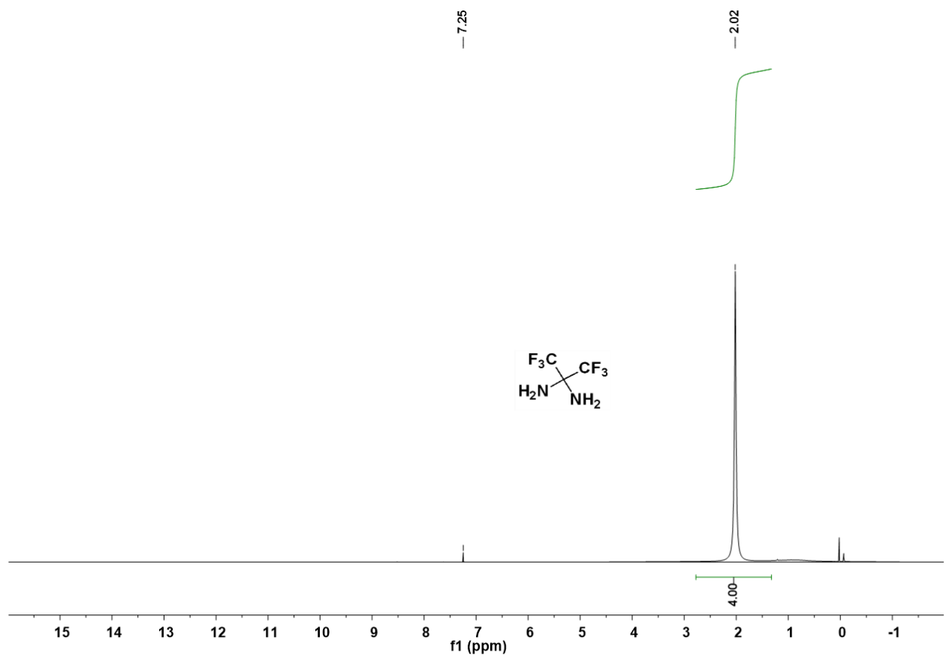
附图1. 2,2-二氨基六氟丙烷¹H NMR图谱(400MHz, CDCl₃)
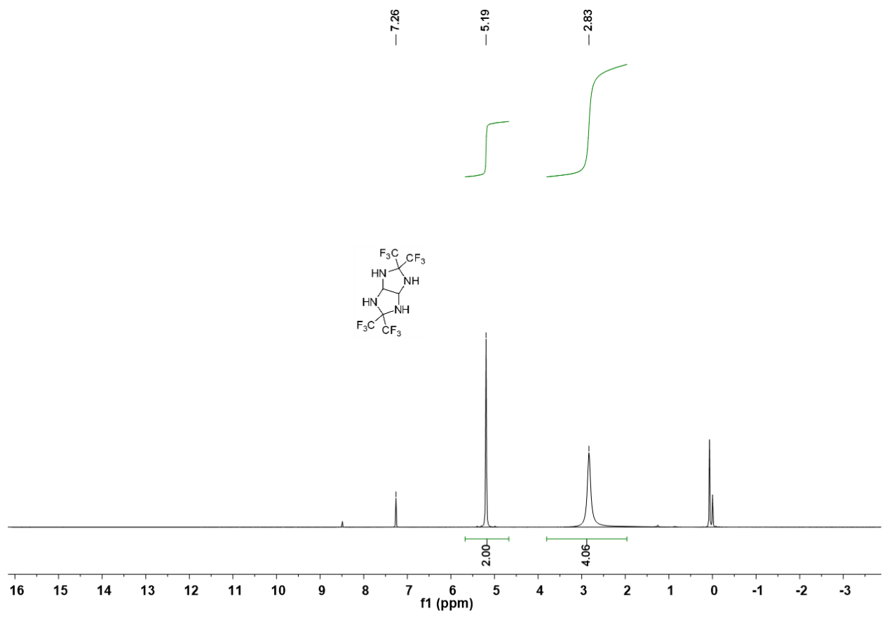
附图2. 3,3,7,7-四（三氟甲基）-2,4,6,8-四氮杂双环[3.3.0]辛烷¹H NMR图谱(400MHz, CDCl₃)

Figure 2. ¹H NMR spectra of 4
附图3. 2,6-二硝基-3,3,7,7-四（三氟甲基）-2,4,6,8-四氮杂双环[3.3.0]辛烷¹H NMR图谱(400MHz, DMSO-d6)

附图4. 2,4,6-三硝基-3,3,7,7-四（三氟甲基）-2,4,6,8-四氮杂双环[3.3.0]辛烷¹H NMR图谱(400MHz, CDCl₃)
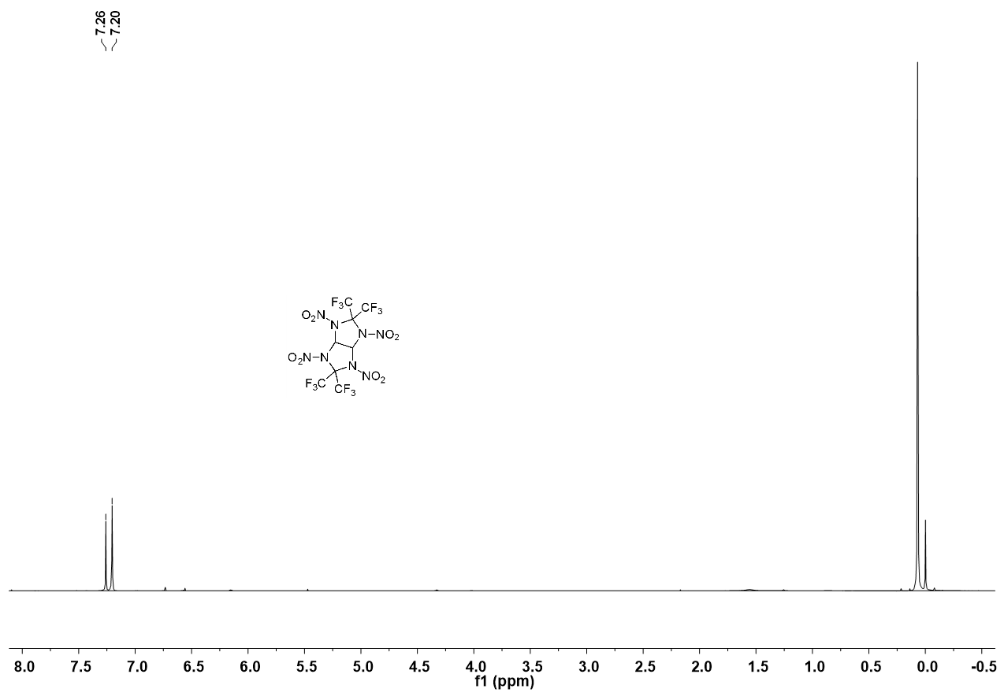
附图5. 2,4,6,8-四硝基-3,3,7,7-四（三氟甲基）-2,4,6,8-四氮杂双环[3.3.0]辛烷¹H NMR图谱(400MHz, CDCl₃)

¹³C NMR Spectra
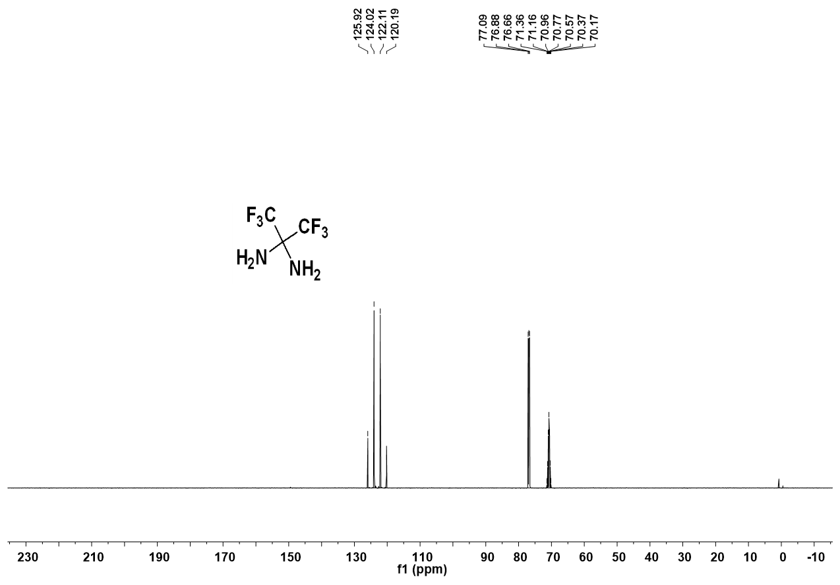
附图6. 2,2-二氨基六氟丙烷¹³C NMR图谱(100MHz, CDCl₃)

附图7. 3,3,7,7-四（三氟甲基）-2,4,6,8-四氮杂双环[3.3.0]辛烷¹³C NMR图谱(100MHz, DMSO-d6)
附图8. 2,6-二硝基-3,3,7,7-四（三氟甲基）-2,4,6,8-四氮杂双环[3.3.0]辛烷¹³C NMR图谱(100MHz, DMSO-d6)

附图9. 2,4,6,8-四硝基-3,3,7,7-四（三氟甲基）-2,4,6,8-四氮杂双环[3.3.0]辛烷¹³C NMR图谱(100MHz, Acetone-d₆)

¹⁵N NMR Spectra
附图10. 2,6-二硝基-3,3,7,7-四（三氟甲基）-2,4,6,8-四氮杂双环[3.3.0]辛烷¹⁵N NMR图谱(75 MHz, DMSO-d6, CH₃NO₂作为内标)

附图11. 2,4,6,8-四硝基-3,3,7,7-四（三氟甲基）-2,4,6,8-四氮杂双环[3.3.0]辛烷¹⁵ N NMR图谱(75 MHz, Acetone-d₆, CH₃NO₂作为内标)

