支撑信息2
1.计算烃类质量热值和比冲的基团贡献参数

附表1 基团贡献法计算烃类标准蒸发焓用到的基团及其对应的贡献值^{[1, 2]}
Table 1 Groups and their contributions (group values G_{i}) to the estimation of properties used in calculations
Group | Δ_{vap}H⁰ /kJ mol⁻¹
CH₃ | 0.217
(CH₃)₂CH | -0.399
(CH₃)₂C | -0.417
CH₂(cyclic) | 3.341
CH(cyclic) | 6.416
C(cyclic) | 7.017
CH(multiring) | -2.225
C(multiring) | -2.030
CH_{cyc}- CH₃ | 0.096
CH_{cyc}- CH₂ | -0.428
CH_{cyc}- CH | 0.153
C_{cyc}- CH₃ | 0.808
C_{cyc}- CH₂ | 0.585

2.机器学习模型预测不同性质的精度
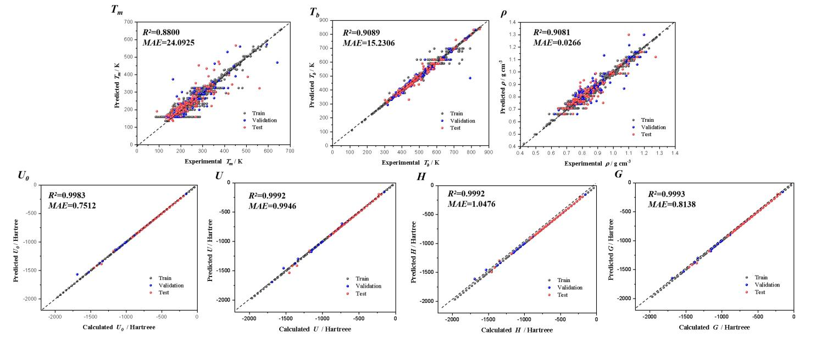
附图1 决策树回归模型预测不同烃类分子性质（T_{m}、T_{b}、ρ、U₀、U、H、G）的预测值与理论计算值结果比较（图中预测误差是模型在测试集上的预测误差）
Fig. 1 Comparison of predicted and experimental values for different properties (T_{m}, T_{b}, ρ,U₀, U, H, G) by Decision Tree Regressor models (the prediction error in the figure is on the test set)

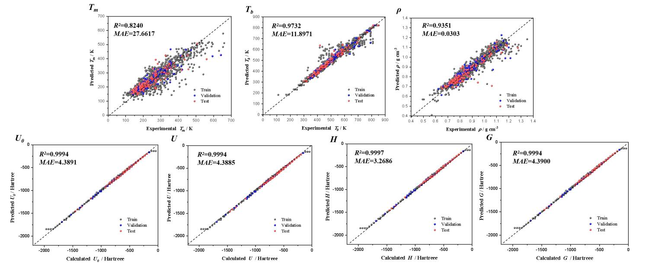
附图2 交叉验证的最小绝对收缩选择算子回归模型预测不同烃类分子性质（T_{m}、T_{b}、ρ、U₀、U、H、G）的预测值与理论计算值结果比较（图中预测误差是模型在测试集上的预测误差）
Fig. 2 Comparison of predicted and experimental values for different properties (T_{m}, T_{b}, ρ,U₀, U, H, G) by Lasso CV models (the prediction error in the figure is on the test set)

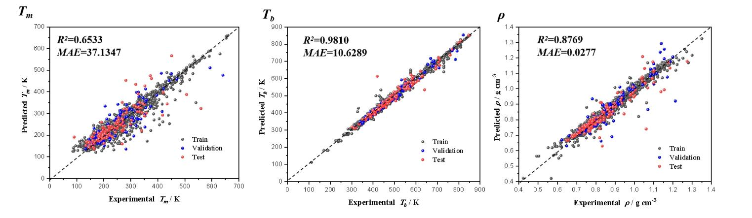
图3 交叉验证的岭回归模型预测不同烃类分子性质（T_{m}、T_{b}、ρ）的预测值与实验值结果比较（图中预测误差是模型在测试集上的预测误差）
Fig. 3 Comparison of predicted and experimental values for different properties (T_{m}, T_{b}, ρ) by Ridge CV models (the prediction error in the figure is on the test set)

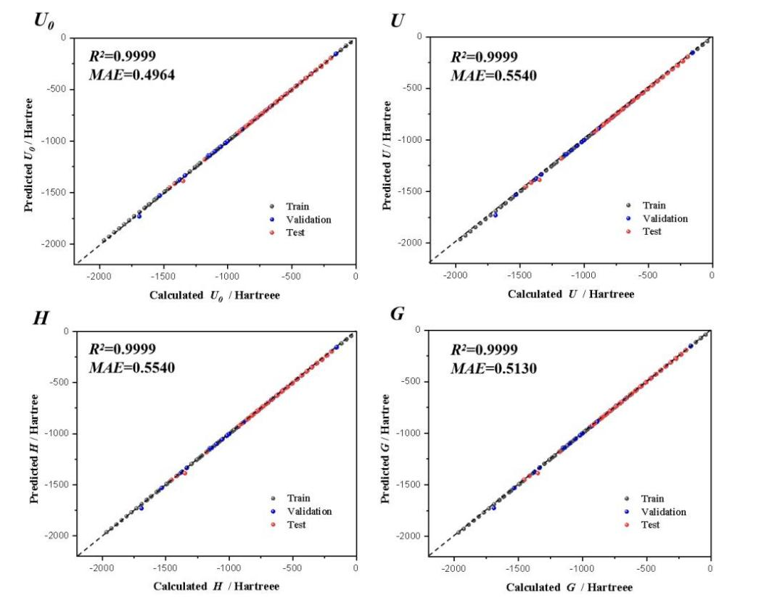
附图4 极限梯度提升回归模型预测不同烃类分子性质（U₀、U、H、G）的预测值与理论计算值结果比较（图中预测误差是模型在测试集上的预测误差）
Fig. 4 Comparison of predicted and experimental values for different properties (U₀, U, H, G) by XGBoost Regressor models (the prediction error in the figure is on the test set)

附表2 决策树回归模型预测不同性质在训练集、验证集、测试集和全集上的R²
Table 2 R² of different properties predicete by Decision Tree Regressor models on the train, validation, test, and total set
 | T_{m} | T_{b} | ρ | U₀ | U | H | G
Train | 0.9433 | 0.9889 | 0.9766 | 0.9999 | 0.9999 | 0.9992 | 0.9999
Validation | 0.7417 | 0.9483 | 0.7762 | 0.9983 | 0.9972 | 0.9983 | 0.9989
Test | 0.8800 | 0.9089 | 0.9081 | 0.9983 | 0.9992 | 0.9992 | 0.9993
Total | 0.9291 | 0.9826 | 0.9647 | 0.9999 | 0.9998 | 0.9999 | 0.9999
附表3 决策树回归模型预测不同性质在训练集、验证集、测试集和全集上的MAEs
Table 3 MAEs of different properties predicete by Decision Tree Regressor models on the train, validation, test, and total set
 | T_{m} | T_{b} | ρ | U₀ | U | H | G
Train | 13.2587 | 5.3309 | 0.0329 | 0.0276 | 0.0276 | 0.0276 | 0.0278
Validation | 25.5762 | 10.3328 | 0.0314 | 1.5536 | 1.7777 | 1.4758 | 1.1166
Test | 24.0925 | 15.2306 | 0.0266 | 0.7512 | 0.9946 | 1.0476 | 0.8138
Total | 14.4791 | 6.0762 | 0.0254 | 0.1401 | 0.1635 | 0.1510 | 0.1515

附表4 交叉验证的最小绝对收缩选择算子回归模型预测不同性质在训练集、验证集、测试集和全集上的R²
Table 4 R² of different properties predicete by Lasso CV models on the train, validation, test, and total set
 | T_{m} | T_{b} | ρ | U₀ | U | H | G
Train | 0.8073 | 0.9524 | 0.9398 | 0.9992 | 0.9993 | 0.9995 | 0.9992
Validation | 0.8508 | 0.9284 | 0.7865 | 0.9993 | 0.9993 | 0.9995 | 0.9993
Test | 0.8240 | 0.9732 | 0.9351 | 0.9994 | 0.9994 | 0.9997 | 0.9994
Total | 0.8067 | 0.9527 | 0.9334 | 0.9992 | 0.9992 | 0.9995 | 0.9992

附表5 交叉验证的最小绝对收缩选择算子回归模型预测不同性质在训练集、验证集、测试集和全集上的MAEs
Table 5 MAEs of different properties predicete by Lasso CV models on the train, validation, test, and total set
 | T_{m} | T_{b} | ρ | U₀ | U | H | G
Train | 25.5036 | 12.8649 | 0.0260 | 4.5413 | 4.5408 | 3.4553 | 4.5420
Validation | 22.6127 | 13.1082 | 0.0313 | 4.3372 | 4.3366 | 3.7269 | 4.3381
Test | 27.6617 | 11.8971 | 0.0303 | 4.3891 | 4.3885 | 3.2686 | 4.3900
Total | 25.5847 | 12.8286 | 0.0255 | 4.5235 | 4.5229 | 3.4596 | 4.5242

附表6 交叉验证的岭回归模型预测不同性质在训练集、验证集、测试集和全集上的R²
Table 6 R² of different properties predicete by Ridge CV models on the train, validation, test, and total set
 | T_{m} | T_{b} | ρ | U₀ | U | H | G
Train | 0.9195 | 0.9907 | 0.9764 | 0.9999 | 0.9999 | 0.9999 | 0.9999
Validation | 0.6969 | 0.9444 | 0.8129 | 0.9999 | 0.9999 | 0.9999 | 0.9999
Test | 0.6533 | 0.9810 | 0.8769 | 0.9999 | 0.9999 | 0.9999 | 0.9999
Total | 0.8884 | 0.9883 | 0.9642 | 0.9999 | 0.9999 | 0.9999 | 0.9999

附表7 交叉验证的岭回归模型预测不同性质在训练集、验证集、测试集和全集上的MAEs
Table 7 MAEs of different properties predicete by Ridge CV models on the train, validation, test, and total set
 | T_{m} | T_{b} | ρ | U₀ | U | H | G
Train | 16.1079 | 6.6727 | 0.0233 | 0.0193 | 0.0192 | 0.0192 | 0.0195
Validation | 29.6335 | 10.6977 | 0.0265 | 0.1644 | 0.1643 | 0.1643 | 0.1641
Test | 37.1347 | 10.6289 | 0.0277 | 0.1380 | 0.1375 | 0.1375 | 0.1390
Total | 18.0385 | 7.0719 | 0.0247 | 0.0325 | 0.0324 | 0.0324 | 0.0327

附表8 极限梯度提升回归预测不同性质在训练集、验证集、测试集和全集上的R²
Table 9 R² of different properties predicete by XGBoost Regressor models on the train, validation, test, and total set
 | T_{m} | T_{b} | ρ | U₀ | U | H | G
Train | 0.9985 | 0.9994 | 0.9296 | 0.9999 | 0.9999 | 0.9999 | 0.9999
Validation | 0.8969 | 0.9633 | 0.8349 | 0.9995 | 0.9996 | 0.9996 | 0.9995
Test | 0.9043 | 0.9815 | 0.9359 | 0.9999 | 0.9999 | 0.9999 | 0.9999
Total | 0.9866 | 0.9970 | 0.9262 | 0.9999 | 0.9999 | 0.9999 | 0.9999

附表9 极限梯度提升回归预测不同性质在训练集、验证集、测试集和全集上的MAEs
Table 9 MAEs of different properties predicete by XGBoost Regressor models on the train, validation, test, and total set
 | T_{m} | T_{b} | ρ | U₀ | U | H | G
Train | 2.4068 | 1.2301 | 0.0244 | 0.0601 | 0.0601 | 0.0591 | 0.0607
Validation | 15.9282 | 7.8294 | 0.0278 | 1.1896 | 1.1487 | 1.1441 | 1.1976
Test | 19.9442 | 9.0034 | 0.0258 | 0.4964 | 0.5540 | 0.5540 | 0.5130
Total | 4.1918 | 1.9490 | 0.0246 | 0.1385 | 0.1393 | 0.1381 | 0.1402

参考文献
[1] Antoine Osmont L C, Iskender Go¨kalp. Physicochemical Properties and Thermochemistry of Propellanes [J]. Energy & Fuel, 2008, 22.
[2] Hukkerikar A S, Sarup B, Ten Kate A, Abildskov J, Sin G, Gani R. Group-contribution+ (GC+) based estimation of properties of pure components: Improved property estimation and uncertainty analysis [J]. Fluid Phase Equilibria, 2012, 321: 25-43.
[3] Savos’kin M V, Kapkan L M, Vaiman G E, Vdovichenko A N, Gorkunenko O A, Yaroshenko A P, Popov A F, Mashchenko A N, Tkachev V A, Voloshin M L, Potapov Y F. New approaches to the development of high-performance hydrocarbon propellants [J]. Russian Journal of Applied Chemistry, 2007, 80(1): 31-37.

